Create index.html:

<!DOCTYPE html>
<html>
<head>
<title>CI/CD Demo</title>
<style>
body{
text-align:center;
font-family:Times New Roman;
background-color:#af0d0d;
}
h1{
color:#0ef777;
}
</style>
</head>
<body>
<h1>CI/CD Pipeline Working</h1>
<h2>Deployed using Jenkins + Docker + Kubernetes</h2>
<p>This webpage is automatically deployed using a CI/CD pipeline.</p>
</body>
</html>

Create a Dockerfile
FROM nginx:latest
COPY index.html /usr/share/nginx/html/index.html
EXPOSE 80

deployment.yaml:

apiVersion: apps/v1
kind: Deployment
metadata:
name: html-demo
spec:
replicas: 2
selector:
matchLabels:
app: html-demo
template:
metadata:
labels:
app: html-demo
spec:
containers:
- name: html-demo
image: swetab84/html-demo:latest
ports:
- containerPort: 80

---
apiVersion: v1
kind: Service
metadata:
name: html-demo-service
spec:
type: NodePort
selector:
app: html-demo
ports:
- port: 80
targetPort: 80
nodePort: 30010

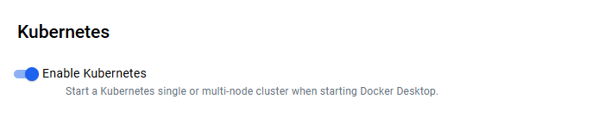

In Jenkins Setting --> Credentials

New Credentials – User name:

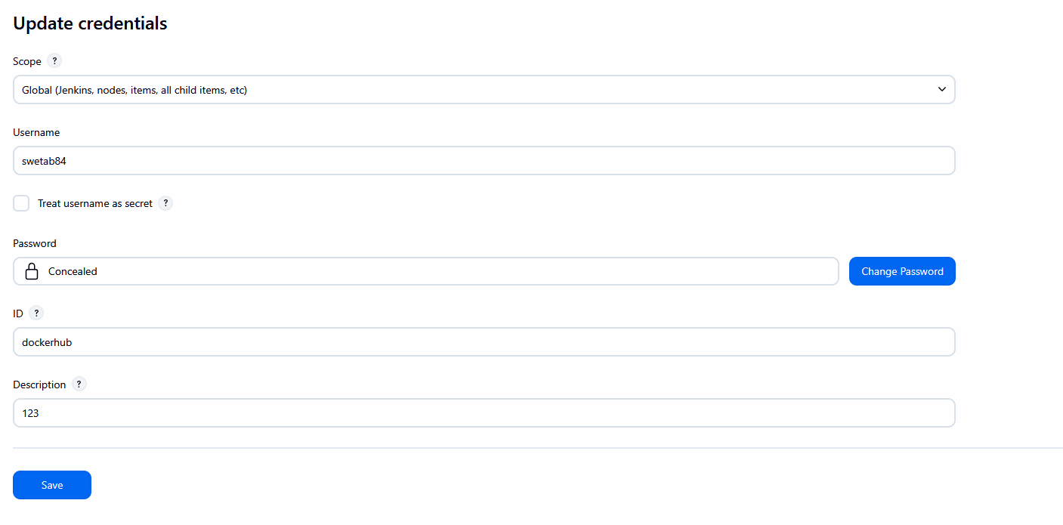

New Credentials – Secret – Broswse C: User->Administrator-->.kube
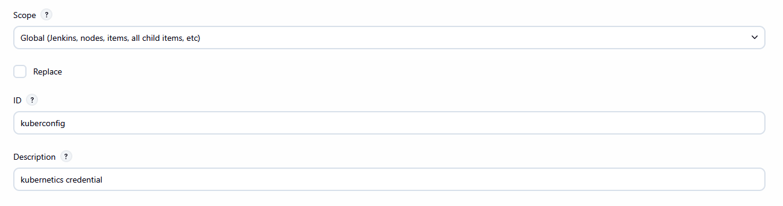

Pipeline:

pipeline {
agent any
environment {
DOCKER_IMAGE = "swetab84/html-demo"
}
stages {
stage('Clone Code') {
steps {
git branch: 'main',
url: 'https://github.com/swetab-max/docker-example.git'
}
}
stage('Build Docker Image') {
steps {
bat 'docker build -t %DOCKER_IMAGE% .'
}
}
stage('Push Image') {
steps {
withCredentials([usernamePassword(credentialsId: 'dockerhub',
usernameVariable: 'USER', passwordVariable: 'PASS')]) {
bat 'docker login -u %USER% -p %PASS%'
bat 'docker push %DOCKER_IMAGE%'
}
}
}
stage('Deploy to Kubernetes') {
steps {
withCredentials([file(credentialsId: 'kuberconfig', variable:
'KUBECONFIG')]) {
bat '''
set KUBECONFIG=%KUBECONFIG%
kubectl apply -f deployment.yaml --validate=false
'''
}
}
}
}
}

